

Agentic Climate Early Warning System for Sri Lanka

Submitted by – Ariwalagan Dhilshan (COBScDS242P-017)
BSc (Hons) Data Science
National Institute of Business Management (NIBM) - NIC
Colombo, Sri Lanka
Date of Submission - 10th of January 2026

A project report submitted to the National Institute of Business management for the partial fulfillment of requirement of BSc (Hons) in Data Science.

DECLARATION

I hereby declare that the work presented in this project report was carried out independently by myself and has cited the work of others and given due reference diligently.

……………………………….
Ariwalagan Dhilshan

………………………………
Date

I certify that the above student carried out his/her project under my supervision and guidance.

………………………………
Supervisor
Mr. Ashan Arthanayake

………………………………
Date
ACKNOWLEDGEMENT

I would like to express my sincere gratitude to my lecturers and especially to my project supervisor, Ms. Ashan Arthanayake, for their guidance and feedback and advice. I would like to extend my gratitude to my fellow classmates with whom I was able to work together. Lastly, I would be remiss in not mentioning my family, especially my mother, without whose support I could not have undertaken the journey of my academics.
ABSTRACT

This project offers an end-to-end agentic climate early warning system for Sri Lanka, generating 1- 7 day rainfall forecasts and then interpreting them into district-level hazard warnings for floods and droughts. This pipeline involves the following components such as to calculate the district-level risk based on the rainfall feature, Hazard Tagging through Data-Driven Thresholds, to develop the Multi-Class District Risk Model, Autonomous Alert Trigger & Explanation through SHAP Top Features, to incorporate Spatio-Temporal Forecasting at the station-level and employ the graph structure of 429 stations. From training logs, it can be seen that the forecasting model has been trained for H=1 to H=7 for validation MAE/RMSE and final test MAE/RMSE for each horizon after training for a historical window of P=30 days. The generation of alerts involves providing an arranged table of alerts that contains probabilities for flood (P_{flood}), drought (P_{drought}), as well as normal weather conditions (P_{normal}). This also involves other thresholds along with possible rolling precipitation for features roll3/roll7/roll30; explanations for top features along with SHAP contributions are also provided. The system also supports a human-in-the-loop step where feedback updates policy thresholds (e.g., flood and drought threshold values set to 0.6 in the policy configuration).
Overall, the project demonstrates how forecasting, probabilistic risk modeling, and explainable autonomous decision logic can be combined into a practical warning workflow suitable for dashboard deployment.

Table of Contents
CHAPTER 1 1
INTRODUCTION 1
1.1 Background 1
1.2 Research Problem 1
1.3 Research Questions 2
1.4 Objectives of the Project 2
1.5 Scope of the Research 3
1.6 Justification of the Research 3
1.7 Expected Limitations 3
CHAPTER 2 4
LITERATURE REVIEW 4
2.1 Introduction to the Research Theme 4
2.2 Theoretical Explanation About Key Concepts 4
2.3 Findings by Other Researchers 5
2.4 The Research Gap 6
2.5 Table for Variables, Their Definitions, and Sources: 7
2.6 Chapter Conclusion 8
CHAPTER 3 8
METHODOLOGY 8
3.1 Introduction 8
3.1.1 Hypothesis 9
3.2 Dataset and Data Sources 11
3.2.1 Primary Data Artifact 11
3.2.2 Core Files and Roles 11
3.2.3 Output Files 11
3.3 Population, Sampling, and Unit of Analysis 12
3.4 Data Preparation and Preprocessing 13
3.4.1 Cleaning and Alignment 13
3.4.2 Feature Transformation 13
3.4.3 Data Split Strategy 15
3.5 Graph Construction 15
3.5.1 Motivation 15
3.5.2 KNN Adjacency Matrix 15
3.6 Forecast Model Design 16
3.6.1 Problem Formulation 16
3.6.2 Training Configuration 16
3.6.3 Loss and Evaluation Metrics 17
3.7 Multi-Horizon Training Strategy 17
3.8 Post-processing of Forecast Outputs 17
3.9 Station-to-District Mapping and District Aggregation 17
3.10 District Feature Engineering 18
3.11 Hazard Label Generation 19
3.12 District Risk Model and Calibration 20
3.13 Agentic Alerting Policy 20
3.14 Explainability Layer 22
3.15 System Evaluation Methodology 23
CHAPTER 4 25
RESULTS AND DATA ANALYSIS 25
4.1 Introduction 25
4.2 Station-level Forecasting Results 25
4.3 District Aggregation Results 29
4.4 District Hazard Labeling Results 29
4.5 District Hazard Model Performance 29
CHAPTER 5 31
DISCUSSION AND RECOMENDATION 31
5.1 Discussion 31
5.2 Recommendations 33
5.3 Conclusions 36
REFERENCES 37

LIST OF TABLES

Table 1 - Variables 7

LIST OF FIGURES
Figure 1: System_Workflow 9
Figure 2: Station_Locations 12
Figure 3 : Sample Station Daily Precipitation 13
Figure 4 : Precipitation Distribution (log1p) 14
Figure 5 : Precipitation Distribution (mm) 14
Figure 6 : Graph Degree Distribution 16
Figure 7 : Stations per District Boxplot 18
Figure 8 : Roll3 Distribution with Flood Threshold 19
Figure 9 : Roll30 Distribution with Drought Threshold 20
Figure 10 : Alert Counts by Hazard Type 21
Figure 11 : Alert Counts by Horizon 22
Figure 12 : Top SHAP Features Frequency 23
Figure 13 : Test MAE by Horizon 24
Figure 14 : Learning Curve (H=1) 25
Figure 15 : Learning Curve (H=2) 26
Figure 16 : Learning Curve (H=3) 26
Figure 17 : Learning Curve (H=4) 26
Figure 18 : Learning Curve (H=5) 27
Figure 19 : Learning Curve (H=6) 27
Figure 20 : Learning Curve (H=7) 27
Figure 21 : Test RMSE by Horizon 28
Figure 22 : Rolling Features and Alerts Sample Precipitation Distribution Timeline 30

CHAPTER 1

INTRODUCTION

1.1 Background
The occurrence of extreme rainfall and drought conditions pose recurrent flood and drought risks in Sri Lanka. Early warning systems can mitigate those risks when an indication about the occurrence of natural disasters along with appropriate warnings and guidelines are provided to decision-makers beforehand. Early warning systems for natural disasters should involve more than forecasting. It should entail forecasting into statements that can be verified by human validation for districts.
The proposed work outlines an agentic climate change early warning system with a model that predicts the rainfall for various forecast Lead Times (1-7 days), a district risk model which transforms the predictions into probabilities of Flood/DR/N, and the alert decision to issue alerts when probabilities cross set thresholds. The system generates a precise alert log with entries for the forecasted hazard type, probability values, corresponding thresholds, and explanations (roll3/roll7/roll30 and rainfall predictions), enabling the operator to know ‘why the model has sounded the alert’.

1.2 Research Problem
Data-driven climate projects tend to limit themselves to the generation of numerical predictions, but the actual process of issuing warnings needs to translate predictions into decisions and handle uncertainty and transparency adequately. “The key question that the solution addresses is “How can the multi-horizon precipitation forecasting system be linked to the automated decision-making process and produce flood/drought warnings at the district-level with justified rationale and adjustable policy thresholds?”
Another application-level consideration is that the warnings issued use a threshold-based approach and thus involve trade-offs in calibration and false alarm rates. This again involves a policy mechanism that has thresholds that can be adjusted based on feedback (such as a policy JSON with Flood=0.6 and Drought=0.6).

1.3 Research Questions
- How can precipitation be forecasted over Sri Lanka using a station graph and a rolling historical window that generates multi-horizon, 1–7 day ahead predictions?
- How can the predictions at station level be aggregated to district level features so that consistent hazard labeling and risk modelling can be allowed?
- How good is the district flood/drought/ normal risk modeling and how can the risk probabilities be used in a policy-driven alerting process?
- Explainability needs to be attached to every alert, as operators need to understand the key factors, such as roll3mm, roll7mm, roll30mm, and predicted rainfall, influencing the warning.

1.4 Objectives of the Project
The objectives of this project are to:
- Build and evaluate a station-level precipitation forecasting model using a graph structure and train it for horizons H=1 to H=7 days using a lookback window P=30.
- Convert station forecasts into district-level predictions and rolling precipitation features suitable for hazard analysis.
- Generate district hazard labels (Flood/Drought/Normal) using data-driven thresholds derived from rolling precipitation statistics.
- Train a district risk classifier and apply calibration for reliable probabilities that support alert decisions
- Implement an agentic alerting layer and dashboard outputs that store probabilities, thresholds, and SHAP-style explanations per alert.

1.5 Scope of the Research
This research addresses short-term precipitation-driven warning within a 1 to 7-day lead time that matches with the operational preparedness and resource allocation decision windows. The system in this report makes use of 429 stations and produces district-level outputs matching administrative decision processes, rather than raw station signals.
The scope includes the full ML-to-decision pipeline: data preparation, graph creation (W_knn10), forecasting training, district aggregation, label generation, risk modeling, autonomous alerts, explainability and dashboard integration. The dashboard itself is treated as an operational interface, but the core scope is the modeling and agentic logic rather than UI design.

1.6 Justification of the Research
This is a valid project because climate prediction only has practical applications if its output is interpretable. The output of this project is helpful since it provides explanations for the risk probability and alerts for the respective regions.
Furthermore, the integration of policy thresholds and feedback updates is also valid due to the need for weather alarm systems, for example, to continually adapt in terms of avoiding false warnings based on the risk tolerance level manifested by stakeholders. The logs also illustrate the change in flooding/drought policy thresholds to 0.6 in the policy update phase.

1.7 Expected Limitations
The first factor is that the hazard label depends on the precipitation rolling threshold instead of the ground truth hit records, which means that “Flood/Drought” represents a rainfall-based classification instead of actual disaster occurrences. The next factor is that the region of interest depends on the accuracy of station mapping, and there are issues with station-matching to districts in the log messages before obtaining the final district files.
Finally, as in the case of all ML solutions, the effectiveness is also dependent on the duration for which the data is created (T total = 732 timesteps in the data, as reflected in the training logs). Space is given to adjust the threshold levels, but complete protection requires constant observation and subsequent retraining of the system.

CHAPTER 2

LITERATURE REVIEW

2.1 Introduction to the Research Theme
Early warning systems are right where climate prediction, risk modeling, and decision science intersect. Climate risk prediction involves the prediction for a meteorological element (precipitation) that is then converted to a function (chances of a flood or drought) and expressed in a form that allows decisions to be informed. The theme for this particular project is the combination of forecast layers with decision layers for explanation.
Unlike traditional dashboards, which represent uninterpreted time series data, the agentic early warning system always involves a decision-component (thresholding of probabilities) and produces alerting results with auditable path-dependent warning explanations. In fact, the result of the alerting process, the alert log, embodies the above-mentioned notion as it records hazard probabilities as well as the reasoned explanations for the particular warning.

2.2 Theoretical Explanation About Key Concepts
Spatiotemporal forecasting models use both temporal dependencies, meaning rainfall over time, and spatial dependencies, meaning interstation’s correlations based on proximity. Locations are linked via adjacency matrices in graph structures, where information is shared through connections based on either proximity or correlations. For this study, the dependency is shown through a KNN-based adjacency matrix included in W_knn10.csv.
Calibration is a concern with regard to the correspondence of predicted probabilities to true frequencies in cases where probabilities with a specific threshold form prediction.
Explanation in decision support systems refers to the capability to explain why a given prediction has been made. In this case, each alert has “top features” as well as corresponding SHAP values that associate hazard probability, rolling precipitation features, and predicted rainfall.

2.3 Findings by Other Researchers
It has been established by research and practice guidelines that a good early warning system is not only a model for forecasting, but it has to be a process that constitutes risk knowledge, warning communication, and preparedness/response (United Nations Office for Disaster Risk Reduction). The Words into Action guidance manual by UNDRR and its checklist on WMO cover such closely related aspects of a warning system that are not only focused on the delivery of values of the hazard but are related to being timely and actionable (UNDRR).
From the machine learning side, the observation is that the precipitation process exhibits both temporal dependency (the current day depends on the previous ones) and spatial dependency (neighborhood Effects) (Shi et al., 2015). Shi et al. proposed the ConvLSTM for precipitation nowcasting to study the effectiveness of modeling space + time jointly for precipitation nowcasting relative to methods that are inherently spatially agnostic (Shi et al., 2015). From the aspect of graph-based machine learning, Spatio-Temporal Graph Convolutional Networks (STGCN) proved the ability of the Graph Convolution layer to represent spatial node relations for modeling sequential patterns in the temporal convolution layer for forecasting tasks (Yu et al., 2018).
​Recent surveys on spatio-temporal graph neural networks report that graph-based spatiotemporal forecasting has become widely used across domains such as traffic, weather, and sensor networks because graphs encode relationships among sensors and support information sharing across connected nodes. These reviews also highlight common design choices such as distance-based KNN graphs, multi-step/horizon-wise forecasting, and the need to evaluate performance across multiple future steps because uncertainty grows with prediction horizons. This supports the design choice in this project to build a KNN graph for stations and train across horizons (H1-H7) rather than focusing only on a single-step forecast (Yu et al., 2018).
Another strong finding in the literature is that operational decisions require probabilities that are calibrated, not only accurate (Guo et al., 2017). Guo et al. showed that modern neural networks can be mis calibrated and that temperature scaling is a simple but effective post-hoc calibration method to improve probability reliability, which is important when decisions use probability thresholds (Guo et al., 2017). This matters for early warning because alerts are often triggered using thresholds (e.g., probability > 0.6), so calibration affects false alarms and missed events (WMO,2017).
​ The importance of explainability is again emphasized in decision support and warning acceptance in operational settings, since users require justifiable arguments to act and be held responsible for (WMO, 2025). In this particular study, the output of the alert stores “top features + SHAP values” per alert, so that it is possible to explain the alert output for a specific district warning within the instance level. In this context, the current research on agent IV disaster/climate decision systems stresses the importance of explaining/traceability and adjusting AI behavior according to human feedback for effective governance and sound operation.
Lastly, a Sri Lanka-based flood prediction task on the North Central Province proves that data-driven methods are a practical possibility, but it also inherits a weakness from previous studies, as it lacked a complete warning system that extends from prediction to producing a standard administrative warning that is well-calibrated along with explanations for each alert (Thilakarathne & Premachandra, 2017).

2.4 The Research Gap
Despite the widespread use of spatiotemporally advanced ML (for example, ConvLSTM or STGCN-based models) for rainfall or flood risk prediction, however, one can note that many existing research contributions seem to only go up until an end-to-end early warning cycle (from knowledge of risk through to forecasting and finally warning communication and preparation) in MHEWS (risk knowledge → forecasting → warning communication → preparedness) which follows best practices for UNDRR and WMO concerning early warning systems, for which there seems to be an understanding communicated through clear UNDRR and WMO guidelines concerning the translation of scientific predictions through effective warning messages for an early warning.
The second gap, which still needs to be filled, relates to the connection between model uncertainty and thresholds of decision. Findings are presented with regards to accuracy/MAE/RMSE, while the process of decision alerting relies on probability thresholds. Even if a model can be considered accurate, though not well-calibrated, its outcome may raise questions. Guo et al. explain how “model calibration, a process similar to temperature scaling, can be useful when making binary decisions based on model prediction, although model calibration isn't a step commonly included in spatiotemporal forecasting algorithms for alert decisions.”
​ A third gap is explainability attached to the final alert decision, not just offline global explanations. For early warning acceptance, stakeholders typically require a reason for each warning-what features drove it, and how strongly-but many forecasting systems do not output per-alert explanations in auditable format.
A fourth gap is limited support for feedback-driven policy updates. MHEWS guidance implies continuous improvement and adjustment based on operational experience, but most ML systems treat warning logic as fixed or require retraining to change alert sensitivity. Recent discussions on agentic-AI emphasize the need for systems that can adapt through governance and human feedback while remaining traceable.
It implements a complete pipeline that addresses these gaps: station-level, multi-horizon forecasting on a graph, STGCN-based design. District-level feature aggregation and hazard labeling, calibrated probabilistic district risk outputs suitable for thresholding, policy-driven alert mechanism and per-alert SHAP explanations stored in an alert log for transparency and auditing.

2.5 Table for Variables, Their Definitions, and Sources:

Variable | Definition | Source
Station | Weather observation node (latitude/longitude) | stations.csv
V | Node-time precipitation matrix (log1p transformed) | V_precip_log1p.csv
W | Graph adjacency matrix (KNN-based) | W_knn10.csv
P | Lookback window size (days) | Training config P=30
H | Forecast horizon (days ahead) | Trained for H=1..7
ypredmm | Predicted precipitation in mm | Alerts file columns
roll3mm/roll7mm/roll30mm | Rolling precipitation features (district) | Alerts file columns
Hazard | Flood/Drought/Normal class | Alerts file column
Table 1 - Variables

2.6 Chapter Conclusion
This chapter has laid down the foundation on which an early warning system with an agentic approach can be developed. Spatiotemporal forecasting is used to create the basis for forecasting, while calibration gives the possibility to calculate probabilities for decision-making thresholds, and explainability gives an opportunity to build trust for practical implementation. The research gap is covered with the proposed workflow for Sri Lanka.

CHAPTER 3

METHODOLOGY

3.1 Introduction

This chapter will describe in detail the methodology followed in designing, building, training, and evaluation, and deploying an agentic climate early warning workflow for Sri Lanka with the objective of providing multi-horizon precipitation forecasting from 1 to 7 days in advance and converting those forecasts to district-level flood/drought warnings along with interpretable explanations and tunable decision thresholds.
The developed workflow is an end-to-end pipeline of the following steps, in order: i) preparation of a dataset for precipitation time series from a station, ii) graph construction to model spatial dependency among stations, iii) training a separate forecasting model for each horizon, iv) transform and export predictions, v) map stations to districts and aggregate the predictions, vi) create hazard labels using rolling precipitation rules, vii) train a calibrated district-level risk model, and viii) generate autonomous alerts with SHAP-based explanation summaries that get shown in the Streamlit application.

Figure 1 : System Workflow

3.1.1 Hypothesis
The hypothesis will be that the independent variables (station-level precipitation forecasts, precipitation windows, graph features of the graph relating to locations), and the relative dependent variables (hazard classifications at the district level, accuracy of the forecast) have no relation to one another. This will be the null hypothesis, and the alternative hypothesis will be that a relation does exist. The hypothesis will be:
- Determining whether a connection exists between connectivity in spatial graph models and precipitation forecasts.
  - Null Hypothesis - Spatial graph connectivity using KNN-based adjacency has no significant relationship with forecast error reduction (MAE, RMSE) compared to station-independent models.
  - Alternative Hypothesis - Spatial graph connectivity using KNN-based adjacency has a significant relationship with forecast error reduction across horizons H=1 to H=7 days.
- Finding whether the forecast horizon affects prediction accuracy.
  - Null Hypothesis - Forecast horizon (1-day to 7-day lead time) has no significant relationship with prediction error metrics (MAE, RMSE).
  - Alternative Hypothesis - Forecast horizon has a significant relationship with prediction error metrics, with longer horizons producing systematically higher errors.
- Analyzing whether rolling precipitation features enhance district-level hazard classification performance.
  - Null Hypothesis - Rolling precipitation features (roll3_mm, roll7_mm, roll30_mm) and their usage have no significant relationship with district classifier accuracy (AUC-ROC, ECE).
  - Alternative Hypothesis - Rolling precipitation features and their usage have a significant relationship with district classifier accuracy, improving flood and drought detection.
- Exploring the difference in feature importance between flood and drought alert generation.
  - Null Hypothesis - The type of hazard (flood vs. drought), rolling window lengths, and their SHAP importance scores do not have a significant relationship with alert decisions.
  - Alternative Hypothesis - The type of hazard (flood vs. drought), rolling window lengths, and their SHAP importance scores have a significant relationship, with short-term features dominating flood alerts and long-term features dominating drought alerts.
- Determining whether model calibration improves probability reliability for alert generation.
  - Null Hypothesis - Temperature Scaling calibration has no significant relationship with Expected Calibration Error (ECE) or probability reliability scores.
  - Alternative Hypothesis - Temperature Scaling calibration has a significant relationship with Expected Calibration Error (ECE), significantly reducing miscalibration and improving alert trustworthiness.

3.2 Dataset and Data Sources

3.2.1 Primary Data Artifact
The system uses a Sri Lanka climate dataset converted into a station-time matrix suitable for machine learning. The processed dataset covers N _{stations} = 429 and T _{days} = 732 daily time steps from 2022-11-11 to 2024-11-11.

3.2.2 Core files and Roles
The modeling pipeline uses the following prepared files:
- stations.csv: station index and coordinates (latitude/longitude) for spatial processing and mapping.
- V_precip_log1p.csv: node-time precipitation matrix where rows are dates and columns are station indices 0 - N-1, transformed using log1p (precipitation sum).
- ​W_knn10.csv: station adjacency/weight matrix built using KNN k=10.
These artifacts separate temporal information (V) from spatial information (W), enabling spatiotemporal learning.

3.2.3 Output Files
- Station-level predictions per horizon
- Converted-to-mm outputs for dashboard
- Station → District mapping file
- District aggregated predictions
- District risk labels
- District alerts: alerts CSV containing probabilities, thresholds, roll features, and explanations
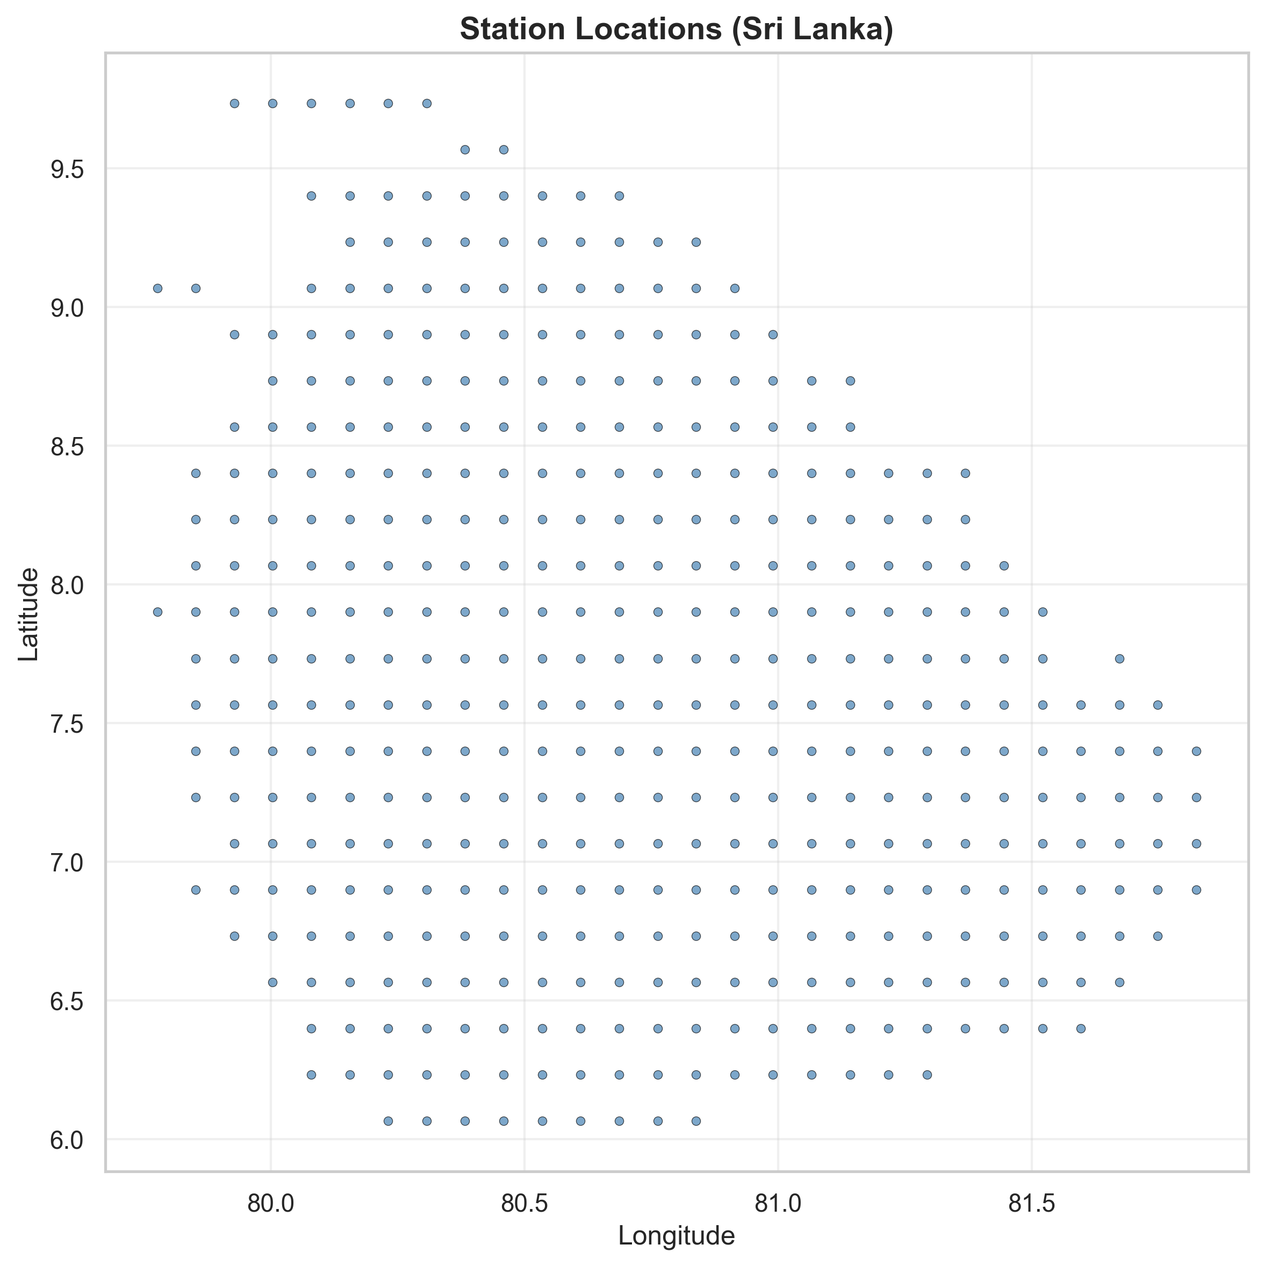
Figure 2: Station_Locations

3.3 Population, Sampling, and Unit of Analysis
In this research, the “population” corresponds to all district-scale daily conditions within the date range of the dataset, and the unit of analysis differs per stage.
- ​ Forecast model unit: station × time (429 stations across 732 days).
- Risk model unit: district × target date × horizon (district aggregated time points derived from station predictions).
- Alert unit: a district-horizon-target-date item emitted by policy when risk probability crosses a threshold, stored as a row in the alert file.

3.4 Data Preparation and Preprocessing

3.4.1 Cleaning and Alignment
The research relies on a consistent daily timeline from 2022-11-11 to 2024-11-11, enabling uniform sliding windows for training and evaluation.
Station coordinates are required both for graph creation and for mapping station predictions into districts
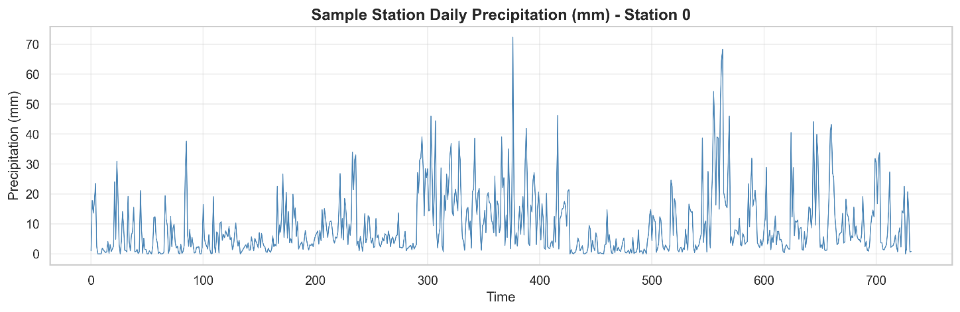
Figure 3: Sample Station Daily Precipitation

3.4.2 Feature Transformation
The precipitation matrix is explicitly recorded as log-transformed: transform = log1p precipitation sum. The log transform is commonly used in rainfall modeling because precipitation distributions are typically heavy-tailed and include many zeros, log1p compresses extremes and stabilizes variance while keeping zeros valid. This transformation is preserved during model training and later reversed when generating “mm” outputs for dashboard and decision logic.
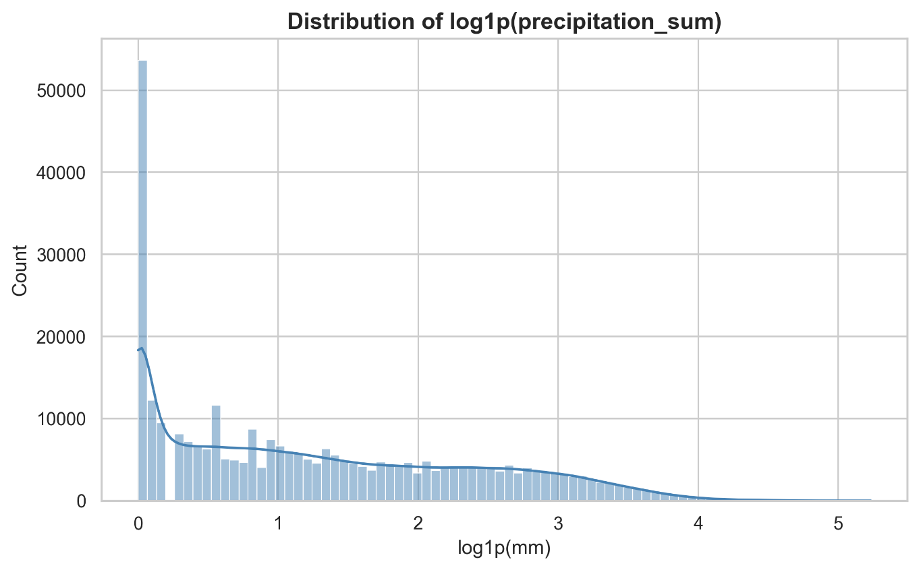
Figure 4 : Precipitation Distribution (log1p)
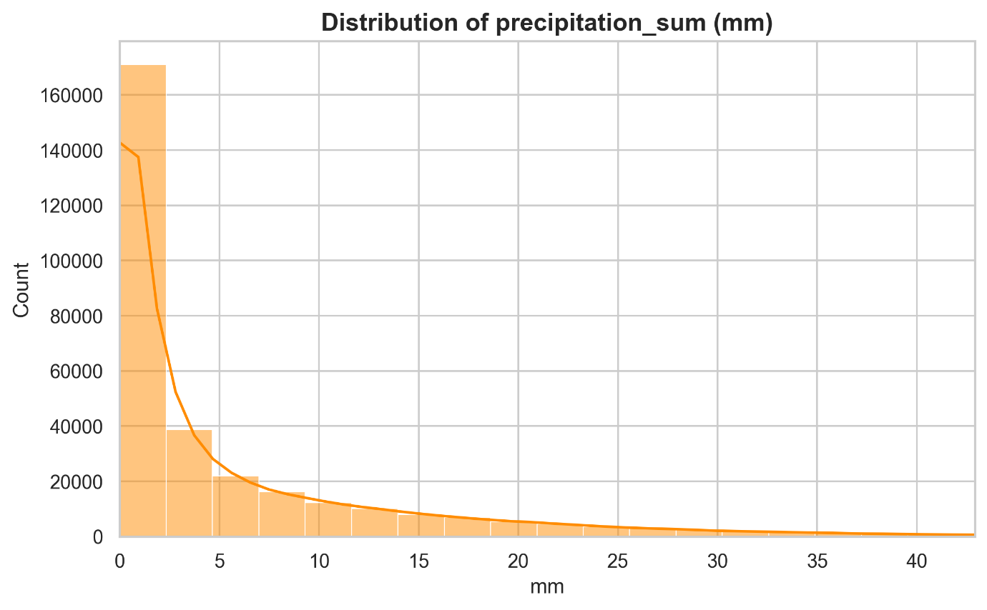
Figure 5 : Precipitation Distribution (mm)

3.4.3 Data Split Strategy
The training scripts report validation MAE/RMSE per epoch and final test MAE/RMSE per horizon, implying a three-way split (train /val /test) across time.
In time series forecasting, splits are done chronologically to prevent leakage. The system’s windowing approach with P=30 also enforces causality by using only past values to predict the future.

3.5 Graph Construction

3.5.1 Motivation
Rainfall prediction for a station is assisted by the information from adjacent stations based on spatial correlations that exist as a result of regional weather patterns and monsoons. These correlations are represented through a graph, whose adjacency matrix gets utilized during the training phase.

3.5.2 KNN Adjacency Matrix
The metadata specifies: knn k = 10, meaning each station is connected to its 10 nearest neighbors.
​A distance-to-weight kernel is controlled by sigmakm ≈ 136.2803, which acts like a scale parameter for how quickly influence decays with distance.
​The resulting matrix is stored in W_knn10.csv and used in every horizon training run.
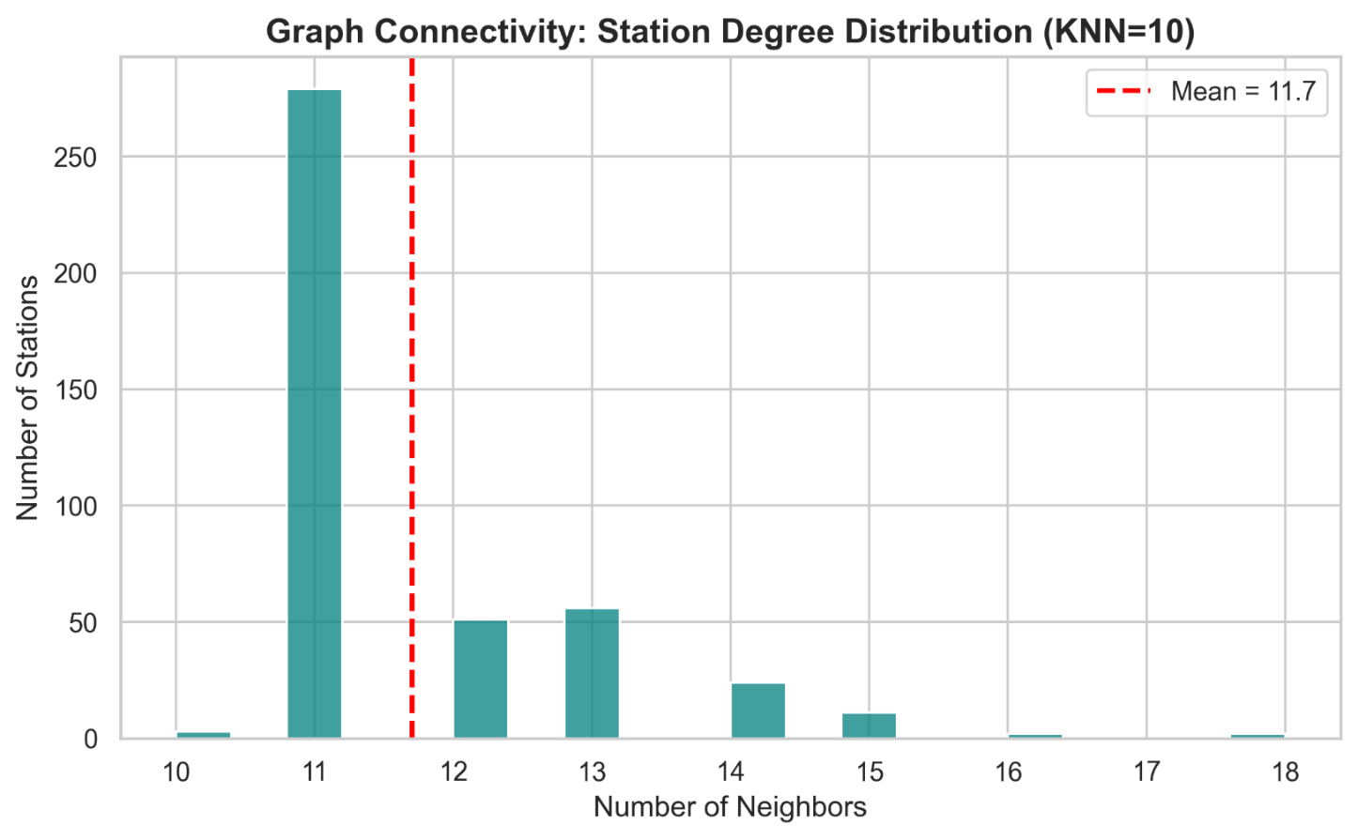
Figure 6 : Graph Degree Distribution

3.6 Forecast Model Design

3.6.1 Problem Formulation
Let V be the precipitation matrix with shape T×N, where T=732 days and N=429 stations.
At each time step t, the model uses the previous P days and predicts precipitation H days ahead, where P=30 and H∈ {1,2,3,4,5,6,7}.
In supervised learning form:
Input: X _{t} =V [t – P + 1:t] (a P×N history window)
Target: Y _{t} =V [t + H] (future precipitation at all stations)

3.6.2 Training Configuration
The project trains one station-level forecast model per horizon using a batch script that runs the training for H=1 - 7, with a fixed lookback P=30. Each horizon model was trained with:
- P = 30
- Epochs = 30
- Batch size = 16
- Learning rate = 0.001
Each epoch shows trainL1 and validation metrics Val _{MAE}, Val _{RMSE}, enabling learning curve analysis and selection of stable training behavior.

3.6.3 Loss and Evaluation Metrics
The training output includes L1 loss as trainL1, and evaluation metrics include MAE and RMSE on validation and test sets.
These metrics are appropriate for continuous precipitation prediction because MAE is robust to outliers and RMSE penalizes large errors more strongly, providing complementary views of performance.

3.7 Multi-Horizon Training Strategy

Multi-horizon forecasting is required because the uncertainty and decision needs differ by lead time. Operational users may need both short-term (1-2 days) and medium short-term (5-7 day) warnings. Instead of using one single model to predict all horizons, the pipeline trained separate models for each horizon so each model can specialize in its own lead-time error characteristics.

3.8 Post-processing of Forecast Outputs
For each trained horizon, station-level predictions were saved as CSV files. These files are later used for downstream district aggregation and dashboarding. Then A dashboard-preparation script saved mm-scale outputs. This indicates the predictions were converted from log1p space back to rainfall mm to make outputs interpretable and usable in threshold-based hazard logic.

3.9 Station-to-District Mapping and District Aggregation
The geospatial workflow inspected the district GeoJSON and A station-to-district mapping was produced with Stations 429 and Missing matches 3 reported. This step is critical because district aggregation quality depends on how many stations contribute to each district and whether any districts are underrepresented.
District aggregation enables:
- district-level predicted precipitation
- rolling feature engineering per district
- direct alignment to administrative decision units (districts)
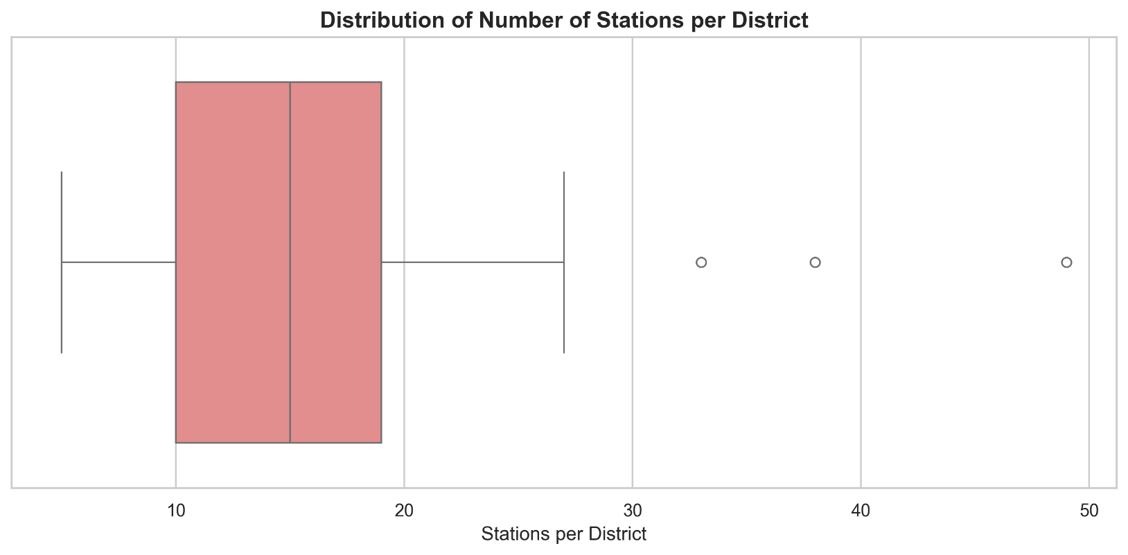
Figure 7 : Stations per District Boxplot

3.10 District Feature Engineering
Flood and drought are not determined by one day of rainfall alone. Flood risk is typically related to short-term accumulation (e.g., last 3 - 7 days), while drought relates to longer-term deficits (e.g., last 30 days). The project encodes this using rolling precipitation aggregates.
The alerts file contains roll features as roll3_mm, roll7_mm, roll30_mm and a single day prediction as y_pred_mm.

3.11 Hazard Label Generation
On account of possible absence of ground-truth labels for hazards (validated flood/drought impact observations) within the dataset, this project employs label construction via thresholding with respect to rolling precipitation indicators.
The label script output indicates thresholds:
- floodroll3P₉₅ = 59.5520
- droughtroll30P₁₀ = 24.3714
This means flood labels are assigned when the district’s short-term rolling precipitation exceeds a high percentile threshold (p95), while drought labels are assigned when long-term rolling precipitation is below a low percentile threshold (p10).
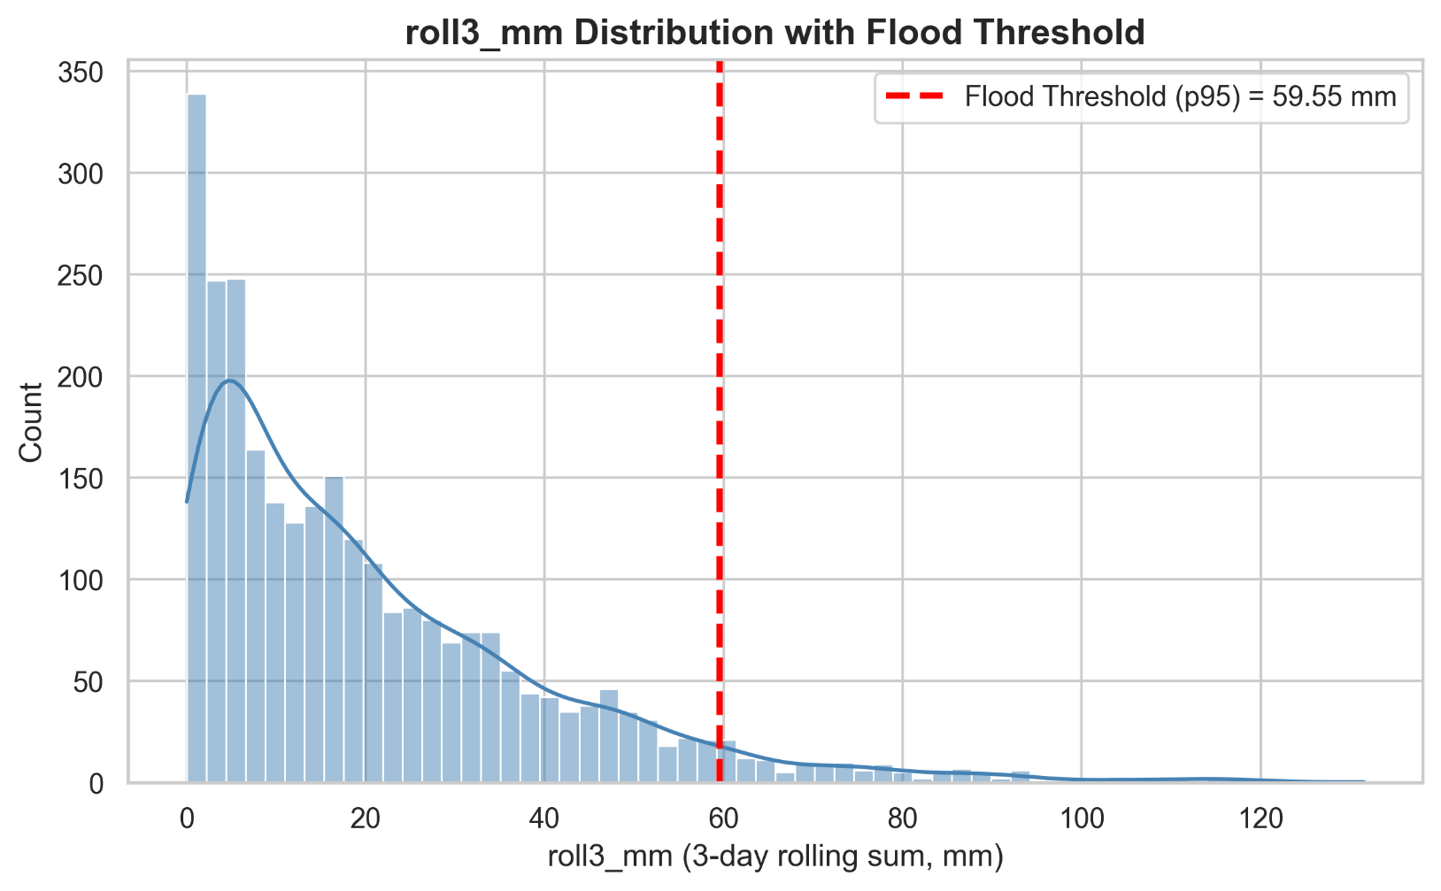
Figure 8 : Roll3 Distribution with Flood Threshold
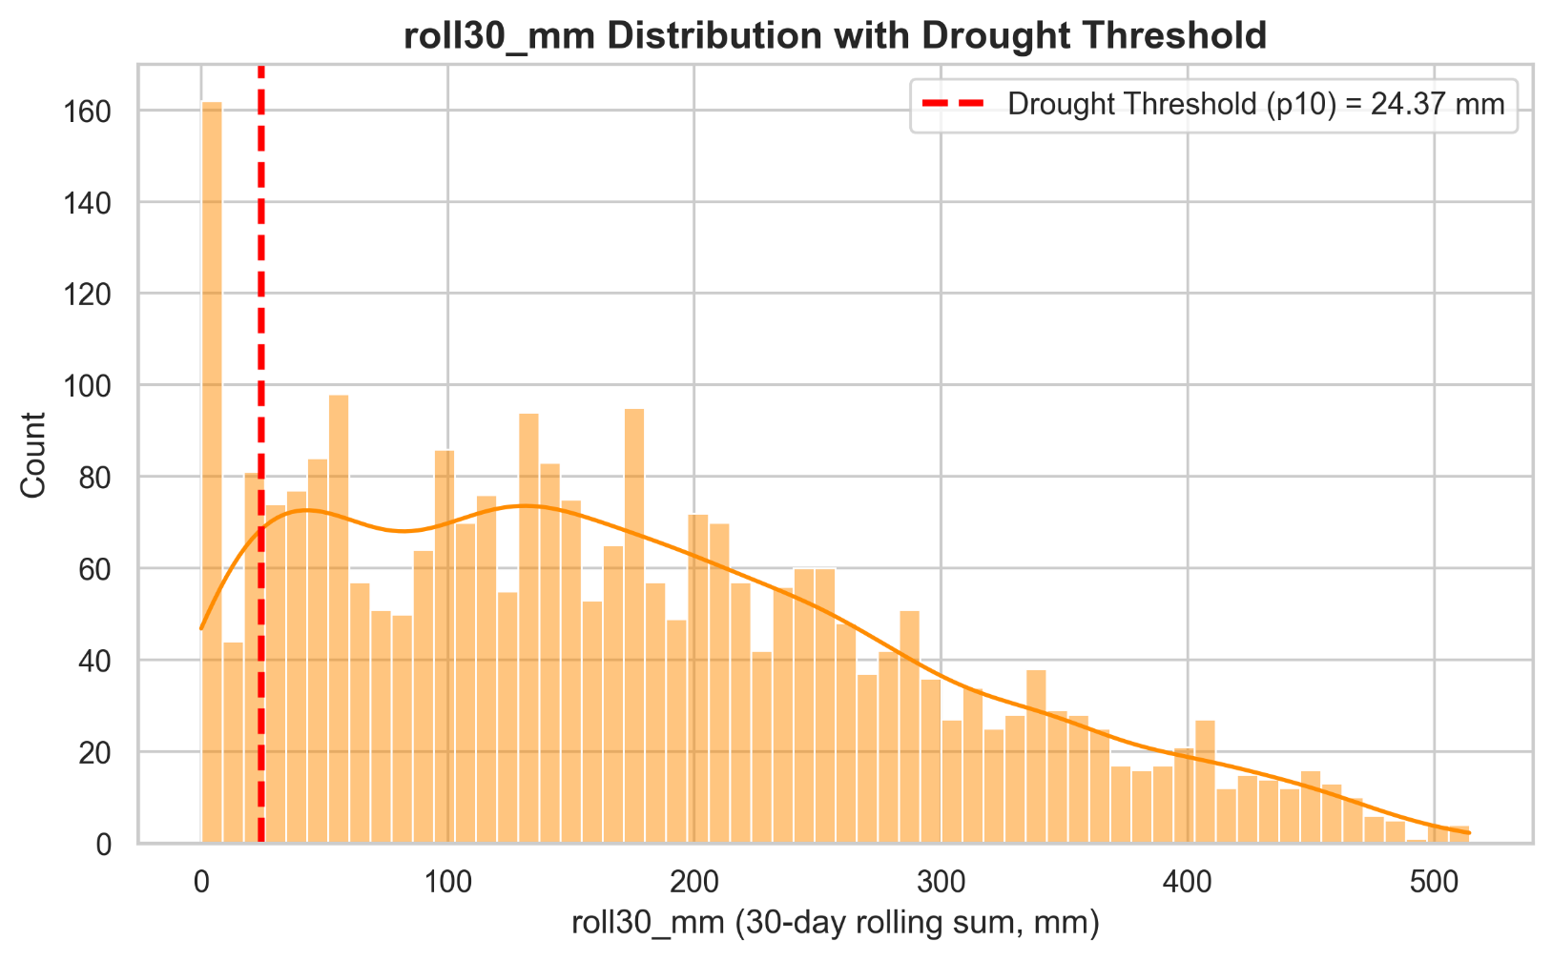
Figure 9 : Roll30 Distribution with Drought Threshold

3.12 District Risk Model and Calibration

The district risk model predicts a multi-class hazard label (Flood / Drought / Normal) using district features derived from forecasts and rolling statistics. The output is a probability distribution used by the alert policy.

3.13 Agentic Alerting Policy
Autonomous alert is formed if the probability of the hazard is beyond the policy threshold for the particular hazard. Policy thresholds are stored, and these can be modified without retraining the models. A feedback step adjusted the policy thresholds and stored them in a JSON policy file, where the Flood threshold and Drought threshold were set to 0.6.

The alert output includes:
- district, origin_date, target_date, horizon_days, hazard
- pFlood, pDrought, pNormal
- threshold_flood, threshold_drought
- y_pred_mm, roll3_mm, roll7_mm, roll30_mm
- explanation_top_features
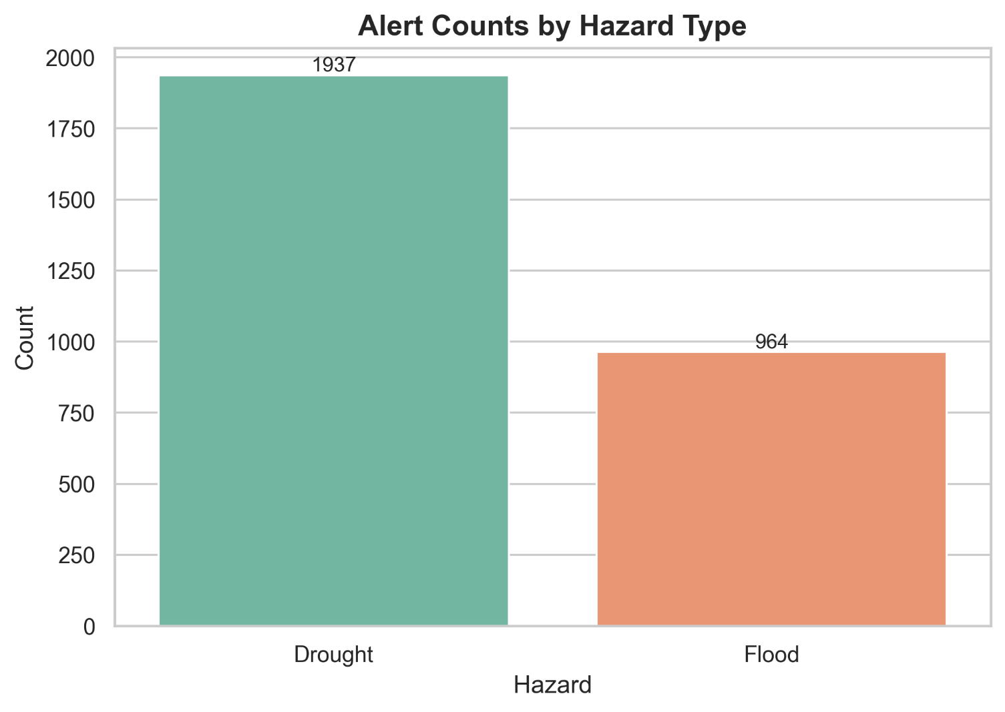
Figure 10 : Alert Counts by Hazard Type
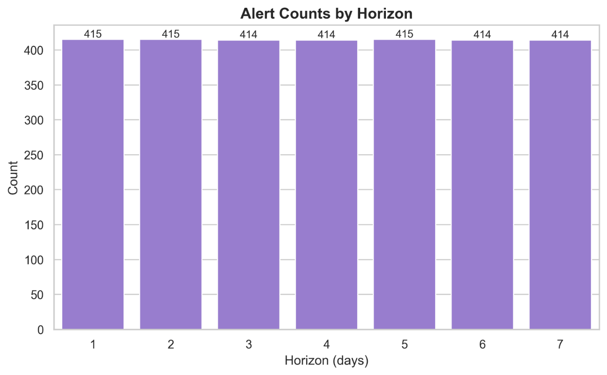
Figure 11 : Alert Counts by Horizon

3.14 Explainability Layer
Accordingly, in the early warning scenario, stakeholders should know why a system issues a warning. Otherwise, blind trust or rejection may occur. Therefore, in each alert, an explanation string that lists the most influential features and their SHAP values is provided. The pipeline has generated alerts with the SHAP explanation and saved them. The output of explainability is local in each alert. Therefore, explanations can be different for each district and date, depending on which rolling feature drives the risk.
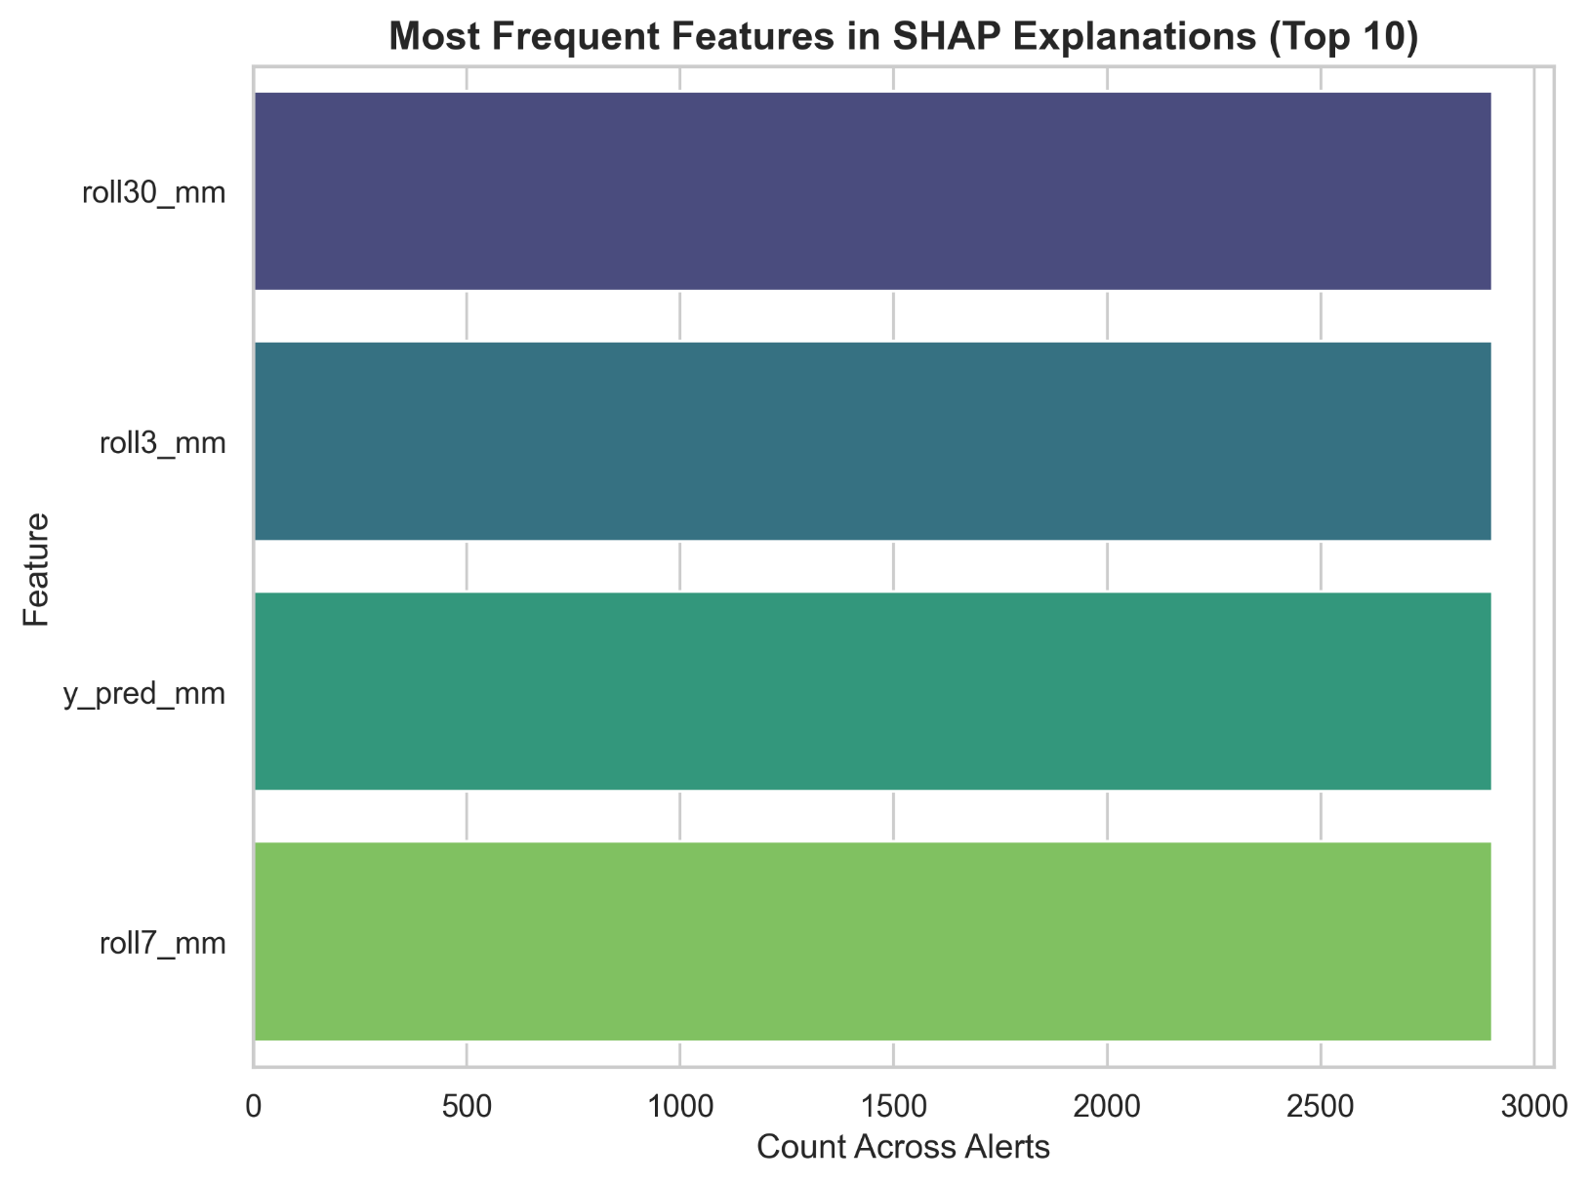
Figure 12 : Top SHAP Features Frequency

3.15 System Evaluation Methodology
The model assessment on the validation dataset utilizes MAE as well as RMSE for a test dataset, while it also evaluates these same quantities for each epoch on a validation set. The reason for using log1p space when training the precipitation values is that it provides less focus on extreme errors while also allowing inverse transformation for ease of interpretation.
The evaluation of districts is carried out by comparing the forecasted outcomes of the hazard with the labels (using the percentile rule on precipitation), and the resulting accuracy is measured by metrics such as macro-F1, which is followed by the conversion of probabilities to alerts.
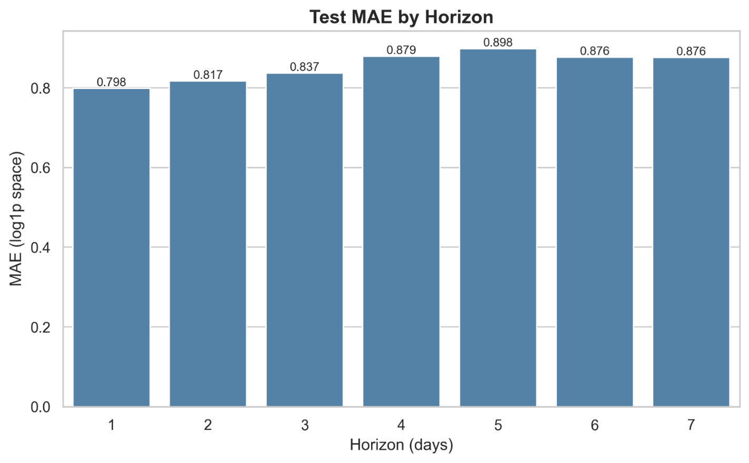
Figure 13 : Test MAE by Horizon

CHAPTER 4

RESULTS AND DATA ANALYSIS

4.1 Introduction
This chapter reports station-level forecasting accuracy across horizons (H1–H7) and then evaluates the district hazard and alerting outputs produced by the calibrated, thresholded agentic layer.

4.2 Station-level Forecasting Results
In the batch training log, it is confirmed that the models were trained for the horizons H = 1 to 7 using parameters lookback = 30, num_epochs = 30, with the same data/graph files, to generate prediction csv files for each horizon separately. In all horizons, it is seen that the value of the error goes on increasing as the lead time goes on increasing. This is expected since the uncertainty grows further into the future
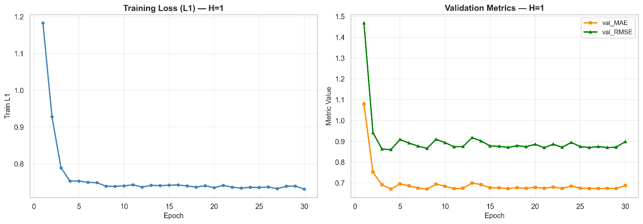
Figure 14 : Learning Curve (H=1)
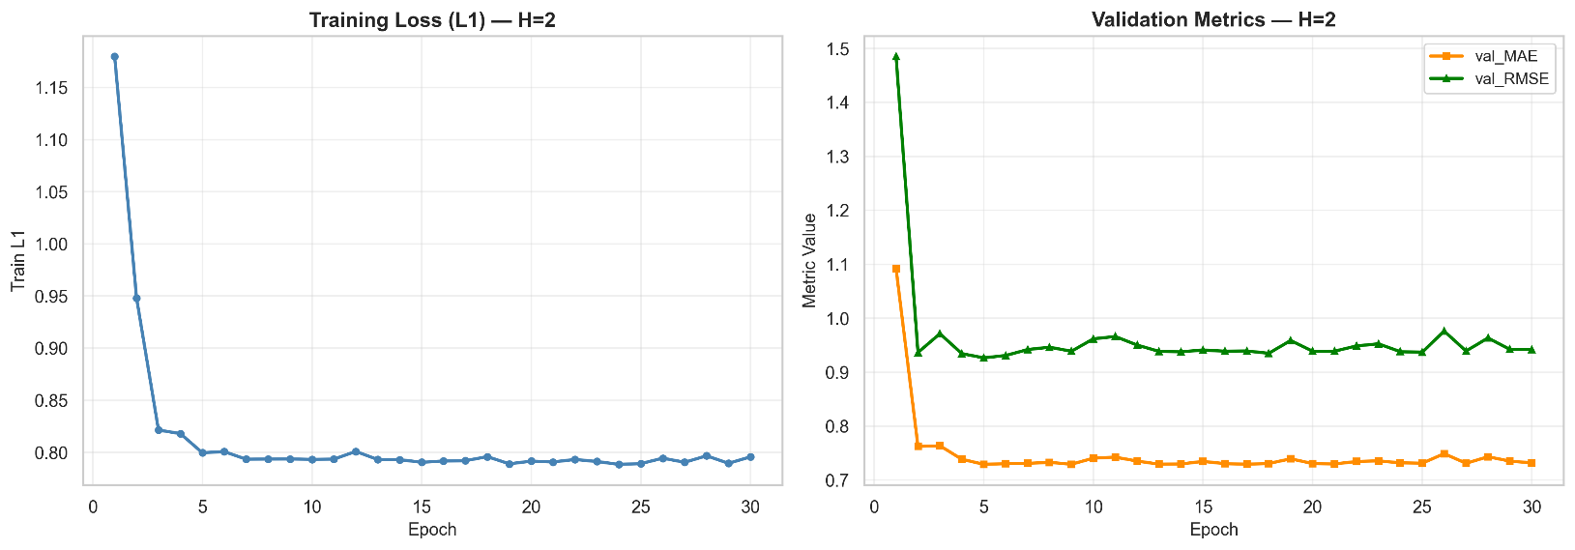
Figure 15 : Learning Curve (H=2)
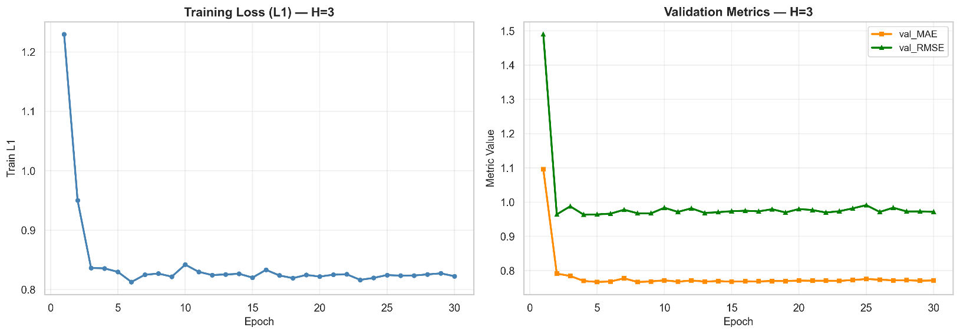
Figure 16 : Learning Curve (H=3)
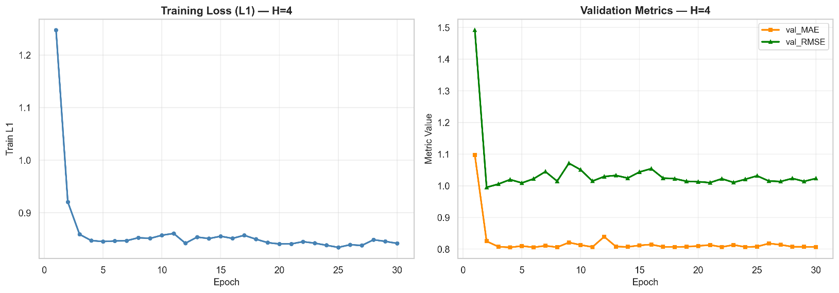
Figure 17 : Learning Curve (H=4)
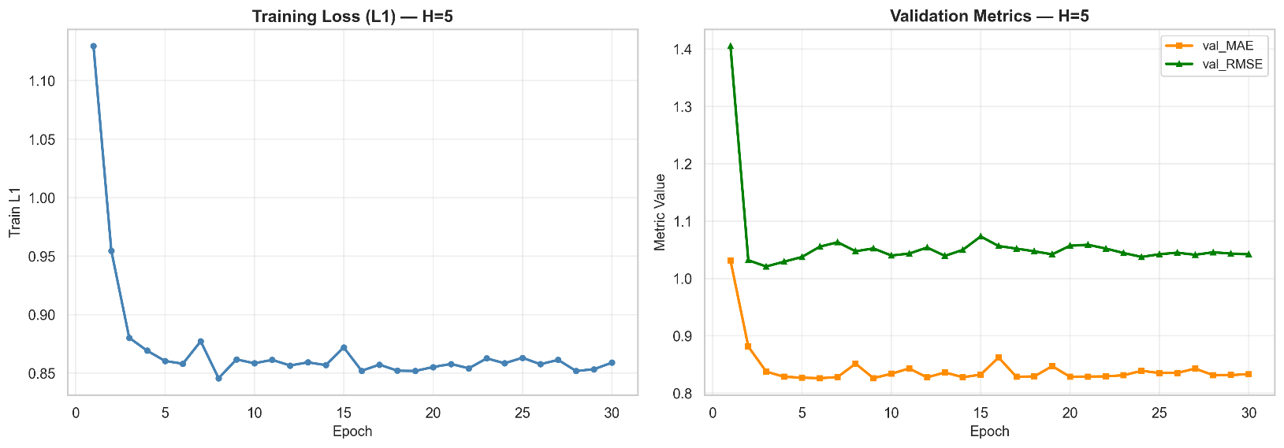
Figure 18 : Learning Curve (H=5)
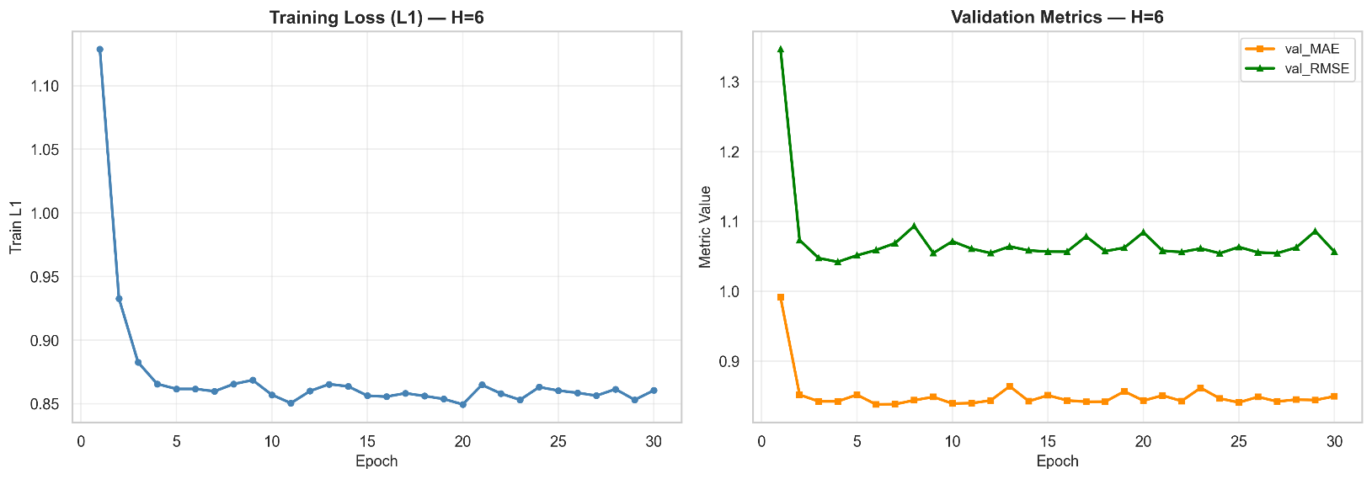
Figure 19 : Learning Curve (H=6)
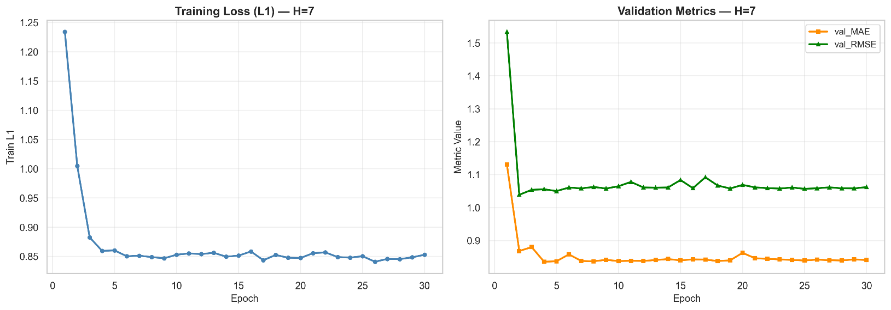
Figure 20 : Learning Curve (H=7)

Reported test metrics from the training run are:
- H1: testMAE 0.7983, testRMSE 1.0175
- H2: testMAE 0.8165, testRMSE 1.0294
- H3: testMAE 0.8368, testRMSE 1.0539
- H4: testMAE 0.8793, testRMSE 1.1106
- H5: testMAE 0.8980, testRMSE 1.1345
- H6: testMAE 0.8765, testRMSE 1.1015
- H7: testMAE 0.8763, testRMSE 1.0980

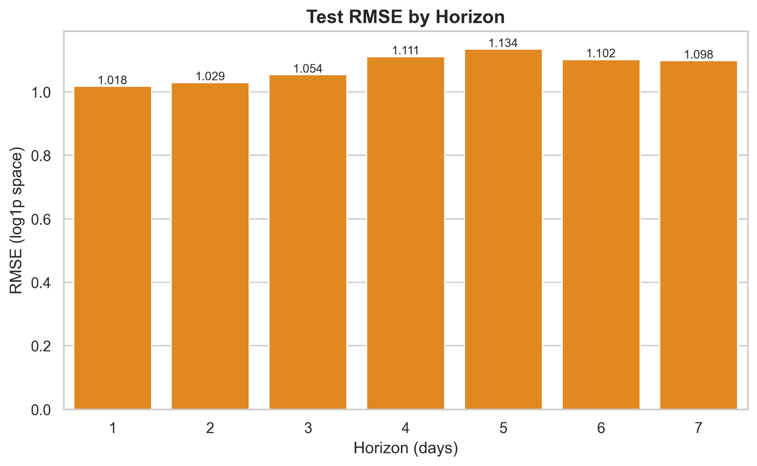
Figure 21 : Test RMSE by Horizon

The observed degradation from H1 toward longer horizons is consistent with compounding uncertainty in rainfall dynamics and the fact that the model must extrapolate beyond the most recent observed context window. Small non-monotonic differences (e.g., H6/H7 slightly better than H5) can occur due to stochastic training effects and the specific test split difficulty for each horizon.

4.3 District Aggregation Results
The pipeline aggregates station predictions into district-level series and produces one district prediction file per horizon, each with 2775 rows saved. This stage enables translating station rainfall forecasts into administrative-unit forecasts required for decision-making. The station-to-district mapping step reports 429 stations with 3 missing matches in the first pass, and the aggregation stage proceeds after the mapping artifacts are prepared. Each district prediction record includes rolling statistics used for risk scoring (3/7/30-day windows)

4.4 District Hazard Labeling Results

District risk labels are generated using percentile-based thresholds computed from aggregated district time-series. The log explicitly records the selected thresholds as floodroll3P₉₅ = 59.5519999 and droughtroll30P₁₀ = 24.371388, which define extreme wet and extreme dry regimes, respectively.
Using 95th percentile for flood-type labeling and 10th percentile for drought-type labeling creates a class definition tied to local climatology, reducing bias from absolute mm cutoffs that may not transfer across districts.

4.5 District Hazard Model Performance

The calibrated district classifier training logs show extremely high validation performance as macro-F1 ≈ 0.9936 for all horizons (H1 - H7). The same training output also reports temperature calibration T = 0.500 and low validation negative log-likelihood values (ValNLL in the range ~ 0.0026 - 0.0044 depending on horizon).
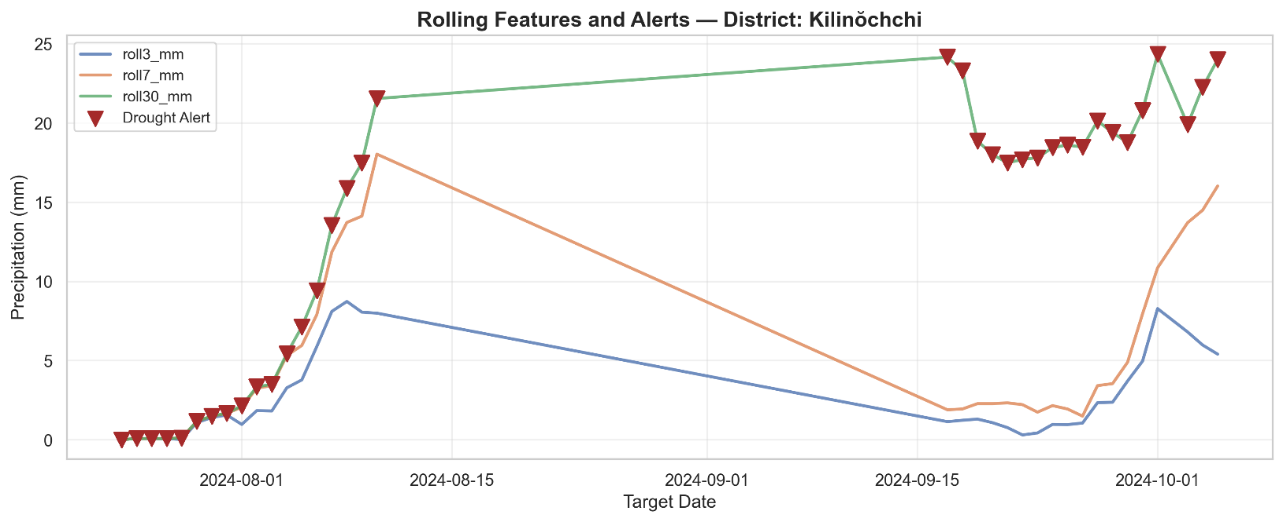
Figure 22 : Rolling Features and Alerts Sample Precipitation Distribution Timeline

CHAPTER 5

DISCUSSION AND RECOMENDATION

5.1 Discussion

This work has addressed the creation and assessment of an end-to-end climate warning system for Sri Lanka based on the agency of multi-hazard precipitation forecast data linked with a decision-making level focused on a district-scale decision-making system producing probabilistic outputs. The work not only focuses on providing a numerical precipitation forecast result but translates the forecast result into a probability of a particular district being under a certain hazard (Flood/Drought/Normal) and further uses the threshold values for producing the alert artifacts.
One major aspect of this work is the design of the system where early warning is conceptualized as a pipeline from prediction to decision instead of using forecasting. The district alert log files that are generated include the predicted hazard, classes, probabilities, thresholds, and explanations based on features. This goes in line with early warning where the warning needs to be both accurate and interpretable.
The station-level precipitation forecasting models trained for horizons H1 - H7 show the expected pattern that prediction difficulty generally increases with lead time, since uncertainty grows further into the future. The reported test MAE/RMSE values remain within a relatively stable range across horizons (e.g., H1 testMAE ≈ 0.798, H7 testMAE ≈ 0.876), indicating that the model maintains usable skill even at 7-day lead time for this dataset and configuration (P=30). Minor non-monotonic differences between horizons are plausible in practice due to stochastic optimization effects and varying difficulty of the held-out test windows.
One methodological strength is that it considers a spatiotemporal setup in which rainfall is modeled over a station graph, where the spatial dependencies of nearby stations contribute to enhancing the quality of the predictions. This agrees with the general findings in Earth system modeling. Holistic spatiotemporal models are important because events propagate in time and influence locations around them.
A key pragmatic step in this work is the conversion of station-level predictions to district-level features that correspond to administrative decision-making units. The early warning pipeline reports issues with station-to-district mapping, such as missing matches during geospatial joining, highlighting that early warning reliability is partly dependent not just on model architecture but also on the quality and coverage of geospatial data and stations represented. However, the aggregation stage nevertheless generated the district prediction output used downstream for labeling, risk modeling, and alerting.
The engineered rolling features roll3mm/roll7mm/roll30mm incorporate domain knowledge. Short-term accumulation is linked to flood potential, while long-term accumulation is linked to drought persistence. Similar rolling features are always observed as the primary explanation factors in the alert log, indicating that the explanations provided by the system are consistent and easier to validate based on hydrometeorological understanding.
Since the exact labels of impact (ground-truth flood/drought occurrences) were not available for this study, the impact terms in this research will be determined based on the rolling precipitation measurements of certain percentiles. This method offers a couple of advantages. Firstly, “extreme wet” and “extreme dry” will be considered relative to climatological conditions, decreasing the reliance on millimeters of general-term flood/drought occurrences. On the negative side, it does not provide a direct interpretation of the result since stated results of the model relate to the constructed terms.
The district risk classifier logs show extremely high validation macro-F1 across all horizons and low validation negative log-likelihood, along with a reported temperature calibration parameter. This indicates the system emphasizes not only classification accuracy but also probability quality, which is essential because alerts are triggered by thresholding probabilities.
A distinctive operational contribution is the policy mechanism: alert thresholds can be updated (e.g., Flood=0.6 and Drought=0.6) without retraining the forecasting model, enabling iterative tuning based on feedback and false-alarm tolerance. This design reflects real early-warning platforms where warnings should trigger early action and may be linked to predefined response plans and resources.
Finally, the explainability layer stores per-alert “top features” and contribution values, enabling auditability and debugging. The presence of roll3mm/roll30mm as dominant drivers in many alerts is consistent with the intended design of translating rainfall accumulation patterns into flood/drought likelihood.

5.2 Recommendations

It is imperative to enhance the validity of the labels using impact information to make the Flood/Drought/Normal district hazard labels more valid in the real-world context. As the existing Flood/Drought/Normal labels are obtained based on rainfall percentile rules based on the rolling rainfall features, the labels indicate meteorological phenomena and not actual disaster occurrences. It is important to incorporate actual impact records such as flood occurrence records, actual declarations of disasters, and agricultural drought values into the study to ensure the labels indicate actual impact occurrences and not rainfall patterns. In the event actual impact records are not available, the use of rainfall values alongside river gauge height and reservoir levels will ensure the labels indicate operational flood risk occurrences through the use of the combination method.
It is also essential to improve geospatial mapping and stations coverage because the quality of geospatial mapping impacts the district aggregation phase, in turn affecting every subsequent phase (features, labels, risk probabilities, and alerts). It is clear from the project log messages that there were incidents of station to district mapping failure in geospatial joins, such as when there were no matches to the station, which shows that geospatial errors have the capability to extend to district-level decision-making artefacts. This problem could be solved in future project deployment through the provision of automatic validation checks to point out unmapped stations and unusual station number distributions by district before the aggregation phase. It would also be important to carry out geospatial operations using the correct projected coordinate reference because there might be errors if operations are done based on incorrectly calculated values such as centroids. Alternatively, when there are still join failure incidents, methods such as assigning a station to the nearest district polygon could be employed.
Incorporating uncertainty and probabilistic forecast outputs would be beneficial for better decision making by incorporating uncertainty already in the precipitation forecast stage instead of just the district classification stage. While the current process already produces probabilistic hazard forecast outputs for the result of the district risk modeling, the precipitation forecast uncertainty tends to increase with forecast distance and may differ considerably by regions and seasons. Future work would be to enable the forecast model to produce prediction intervals for forecasts, such that the district risk modeling model would take not only the forecast outputs but also feature inputs with a notion of uncertainty.
Evaluating calibration and thresholds using operational metrics is particularly important because the system’s alerting behavior is explicitly driven by probability thresholds. The project already supports policy-based threshold updates (e.g., Flood and Drought thresholds adjusted to 0.6), demonstrating that alert frequency and false-alarm tradeoffs depend heavily on threshold choice. Future evaluation should therefore include operational warning metrics such as false alarm rate, missed event rate, average lead time, and cost-sensitive utility measures, rather than relying mainly on classification metrics like macro-F1. Threshold tuning should then be performed through systematic validation against these operational metrics and stakeholder risk tolerance, ensuring that policy updates are evidence-based rather than ad-hoc.
Increasing the utility of explanations for the operators is advisable as an aid to building trust, usability, and audit trails in actual operational scenarios. In the existing alert log system, the “top features” and contribution-type values of hazard probabilities to drivers such as roll3mm, roll7mm, roll30mm, and rainfall are already stored, which helps in maintaining technical-level transparency to an extent. In the future, there is scope for seeking explanations based on the above and other similar values and conveying them in forms easier for the operators to grasp and understand, like templates of short natural-language-style rationales, as “High short-term accumulation and high rainfall led to flood risk” while retaining traceability to the underlying feature values. Moreover, the trend graphs of the alert times around the alert times for the district, including roll3/roll7/roll30 and rainfall, can aid the operators in ascertaining the match of the alert sequence and their perception of the situation through visual confirmation. Lastly, automated checks need to be included in the system whereby potential irregularities in the explanation, like a drought alert led mostly by the feature of high roll3mm values, should alert the system regarding the need to scrutinize the alert system.
This would involve aligning alerts with early action workflows, since warning systems are most effective when they trigger pre-defined actions rather than only producing informational outputs. Because the system already produces district-level hazard probabilities and policy-triggered alerts, it can be extended to attach recommended early actions such as preparedness steps, resource staging, or communication triggers and then log whether actions were taken and what outcomes followed. This creates a measurable feedback loop that can support continuous policy refinement-including threshold adjustment and alert rule tuning-based on real operational effectiveness rather than only offline metrics.
The enhancement of generalization and robustness performance becomes all the more important in view of the changes that could occur in the regime shifts of the climate, rare events of extremes, as well as the non-stationarity of rainfall processes. The project recognizes that performance has implications based on the length of the dataset, including the need to monitor robustness through periodic retraining, which applies to most ML-based decision systems that work in variable or dynamically changing processes. Future research efforts could include improving the coverage of the training set where possible, stressing the need to undertake periodic retraining, while conducting stress tests of rainfall seasons of extremes and rare-event intervals to better grasp failure performances of these ML-based systems that operate at periods of high-impact extremes.

5.3 Conclusions

This study has made clear that a successful climate change early warning solution involves more than precipitation accuracy. It involves a full chain of processing precipitation forecasts to provide risk probabilities at a district level and a warning decision at an appropriate level. Through Multi-Horizon Station Forecasting (H=1-7) with district-level aggregation and a risk calibration mechanism with a policy-based thresholding solution, a successful climate change early warning solution has been exemplified.
What makes the proposed method particularly strong is that every alert it produces contains not only the hazard classification (Flood/Drought/Normal) but also traceable information of probabilities, thresholds, and important key drivers like the rainfall predictions and rolling precipitation values. It should be noted that such transparency and human intervention in interpreting warnings are even more necessary during the execution phase of emergency response, namely the early warnings process itself.
Despite this, it is clear that the research also points to critical limitations that shape the reliability of operations. Specifically, the labels are determined from the use of rainfall-related percentile values rather than the actual impact of disasters on the population, while the problem of matches from the geospatial layer to the district layer might have ramifications at the aggregation level for the related district-level decision.
In general, the result suggests there is a good basis to believe an agentic, explainable, and policy-tunable early warning system can enhance the use of climate prediction information with an interpretable, tunable, and learnable warning system at the district level.

REFERENCES

- United Nations Office for Disaster Risk Reduction (UNDRR). (2025). Words into action guidelines: Multi-hazard early warning systems. https://www.undrr.org/
- World Meteorological Organization (WMO). (2017). Multi-hazard early warning systems: A checklist. WMO-No. 1206.
- Shi, X., Chen, Z., Wang, H., Yeung, D.-Y., Wong, W., & Woo, W. (2015). Convolutional LSTM network: A machine learning approach for precipitation nowcasting. Advances in Neural Information Processing Systems, 28, 802–810.
- Yu, B., Yin, H., & Zhu, Z. (2018). Spatio-temporal graph convolutional networks: A deep learning framework for traffic forecasting. Proceedings of the 27th International Joint Conference on Artificial Intelligence (IJCAI)
- Capone, V., Casolaro, A., & Camastra, F. (2025). Spatio-temporal prediction using graph neural networks: A survey. Neurocomputing, 643, Article 130400. https://doi.org/10.1016/j.neucom.2025.130400
- Guo, C., Pleiss, G., Sun, Y., & Weinberger, K. Q. (2017). On calibration of modern neural networks. Proceedings of the 34th International Conference on Machine Learning, 70, 1321–1330. https://proceedings.mlr.press/v70/guo17a.html
- Li, B., Ma, J., Yin, K., Xiao, Y., Hsu, C.-W., & Mostafavi, A. (2025). Disaster management in the era of agentic AI systems: A vision for collective human-machine intelligence for augmented resilience (arXiv:2510.16034). arXiv. https://arxiv.org/abs/2510.16034 Early warning of complex climate risk with integrated artificial intelligence (2025).
- Thilakarathne, D., & Premachandra, H. K. A. (2017). Predicting floods in North Central Province of Sri Lanka using machine learning and data mining methods.
- Kipf, T. N., & Welling, M. (2017). Semi-supervised classification with graph convolutional networks. Proceedings of the 5th International Conference on Learning Representations (ICLR). https://openreview.net/forum?id=SJU4ayYgl
- Li, Y., Yu, R., Shahabi, C., & Liu, Y. (2018). Diffusion convolutional recurrent neural network: Data-driven traffic forecasting. Proceedings of the 6th International Conference on Learning Representations (ICLR). https://openreview.net/forum?id=SJiHXGWAZ
- Wu, Z., Pan, S., Long, G., Jiang, J., & Zhang, C. (2019). Graph WaveNet for deep spatial-temporal graph modeling. Proceedings of the Twenty-Eighth International Joint Conference on Artificial Intelligence (IJCAI), 1907–1913. https://doi.org/10.24963/ijcai.2019/264
- Bai, L., Yao, L., Li, C., Wang, X., & Wang, C. (2020). Adaptive graph convolutional recurrent network for traffic forecasting. Advances in Neural Information Processing Systems, 33, 17804–17815.
- XIII. Reichstein, M., Camps-Valls, G., Stevens, B., Jung, M., Denzler, J., Carvalhais, N., & Prabhat. (2019). Deep learning and process understanding for data-driven Earth system science. Nature, 566(7743), 195–204. https://doi.org/10.1038/s41586-019-0912-1
- Rasp, S., Pritchard, M. S., & Gentine, P. (2018). Deep learning to represent subgrid processes in climate models. Proceedings of the National Academy of Sciences, 115(39), 9684–9689. https://doi.org/10.1073/pnas.1810286115
- Lundberg, S. M., & Lee, S.-I. (2017). A unified approach to interpreting model predictions. Advances in Neural Information Processing Systems, 30, 4765–4774.

